**Maharaja Agrasen Institute of Technology**

**B.Tech (CSE)**

**Fifth Semester**

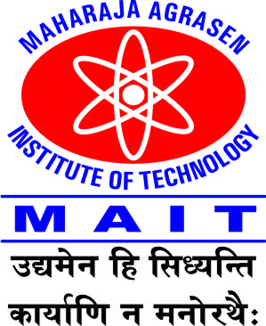

**Assignment 2**

**Subject: Industrial Management (ETMS 311)**

**Submitted By: Submitted To:**

Name of student: Faculty : Dr. Anju Bharti/Ms.Kalpana Sharma

Enrollment No: Asst. Professor,MBA,MAIT

**Maharaja Agrasen Institute of Technology**

**B.Tech (CSE), Fifth Semester (All sections)**

**Assignment II**

**Subject : Industrial Management**

**Subject code : ETMS 311 Full marks:20**

Attempt all questions:

1. How do work study and measurement will be used by industrial engineers? What is the relevance of time study in industry?
2. What is ‘Total Quality Management’. Mention its principles. How it can bring overall growth in the company.
3. Write short notes on the following:
4. Quality Control
5. Taguchi Philosophy
6. Benefit of Quality Circle
7. Kanban System
8. Benchmarking
9. What do you think are some of the biggest reasons that employees are resistant to change?

Instructions:

1. Use A4 size blank sheet. Scan and convert to Pdf for submission at moodle.
2. Use cover page with your name, university enrollment and section.
3. Mention faculty name too.
4. Handwritten only.
5. Submit before 15th November, 2021.